**What is IP Security (IPSec)?**

* Internet Protocol (IP) is the common standard that controls how data is transmitted across the internet.
* IPSec is a set of protocols designed to secure network connections by enhancing the Internet Protocol (IP) with encryption and authentication.
* It encrypts data at the source, decrypts it at the destination, and verifies the data's origin, ensuring secure and reliable communication.

**Why is IPSec Important?**

It is important because it helps keep your data safe and secure when you send it over the Internet or any network. Here are some of the important aspects why IPSec is Important:

* IPSec protects the data through Data Encryption.
* IPSec provides Data Integrity.
* IPSec protects from [Cyber Attacks](https://www.geeksforgeeks.org/what-is-a-cyber-attack/).

**IPSec Connection Establishment Process :**

IPSec secures communication over the internet by authenticating and encrypting each packet during a session. Setting up an IPSec connection happens in two phases:

**Phase 1: Establishing the IKE Tunnel**

This phase creates a secure channel (IKE tunnel) for further negotiations. It can operate in two modes:

1. **Main Mode:** Main Mode is a six-message exchange procedure that is more secure than Basic Mode, although at the cost of a longer session, since identity information is transmitted during negotiations.
2. **Aggressive Mode:** Aggressive Mode takes lesser time with the exchange of three messages and is less secure since more information like identity is disclosed during the course of negotiation.
   * .

**Phase 2: Establishing the IPSec Tunnel**

This phase (called Quick Mode) sets up the actual IPSec tunnel to secure data transfer. It operates in two modes:

1. **Tunnel Mode**:

Tunnel Mode is an IPSec mode where the entire original IP packet, including its header and data, is encapsulated within a new IP packet with a new header. This provides full encryption and is primarily used in **site-to-site VPNs** to secure communication between networks.

1. **Transport Mode**:

Transport Mode is an IPSec mode that encrypts only the data payload of the IP packet, leaving the original header unchanged. It is mainly used for **end-to-end communication** between individual devices, ensuring secure data exchange without modifying routing information.

**IPSec Architecture :**

**IPSec (IP Security) architecture** uses two protocols to secure the traffic or data flow. These protocols are ESP (Encapsulation Security Payload) and AH (Authentication Header). IPSec Architecture includes protocols, algorithms, DOI, and Key Management. All these components are very important in order to provide the three main services:

* Confidentiality
* Authentication
* Integrity

**IP Security Architecture:**   
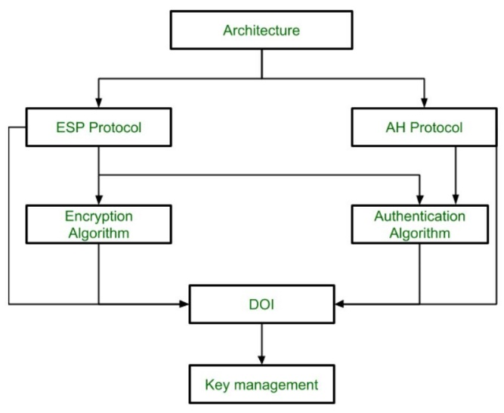   
**1. Architecture:** Architecture or IP Security Architecture covers the general concepts, definitions, protocols, algorithms, and security requirements of IP Security technology.

**2. ESP Protocol:** It provides data integrity, encryption, authentication, and anti-replay. It also provides authentication for payload. It is implemented in either two ways:

* ESP with optional Authentication.
* ESP with Authentication.

**Packet Format:**   
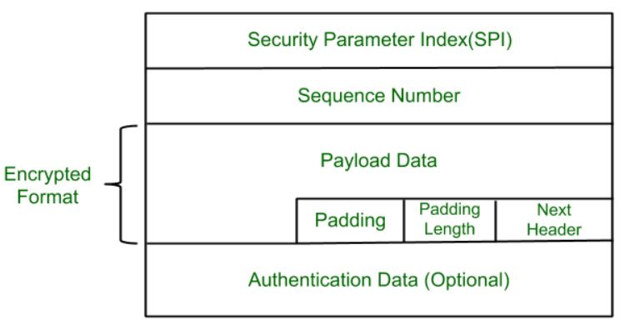 

* **Security Parameter Index(SPI):** It is used to give a unique number to the connection built between the Client and Server.
* **Sequence Number:** Unique Sequence numbers are allotted to every packet so that on the receiver side packets can be arranged properly.
* **Payload Data:** Payload data means the actual data or the actual message. The Payload data is in an encrypted format to achieve confidentiality.
* **Padding:** Extra bits of space are added to the original message in order to ensure confidentiality. Padding length is the size of the added bits of space in the original message.
* **Next Header:** Next header means the next payload or next actual data.
* **Authentication Data** This field is optional in ESP protocol packet format.

**3. Encryption algorithm: The encryption** algorithm is the document that describes various encryption algorithms used for Encapsulation Security Payload.

**4. AH Protocol:** AH (Authentication Header) Protocol provides both Authentication and Integrity service. Authentication Header is implemented in one way only: Authentication along with Integrity.   
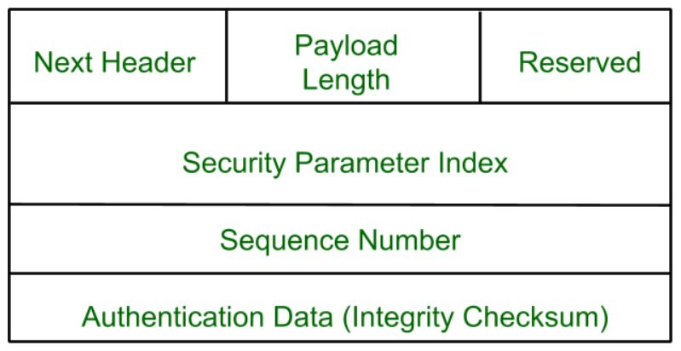   
Authentication Header covers the packet format and general issues related to the use of AH for packet authentication and integrity.

**5. Authentication Algorithm:** The authentication Algorithm contains the set of documents that describe the authentication algorithm used for AH and for the authentication option of ESP.

**6. DOI (Domain of Interpretation):** DOI is the identifier that supports both AH and ESP protocols. It contains values needed for documentation related to each other.

**7. Key Management:** Key Management contains the document that describes how the keys are exchanged between sender and receiver.

**Uses of IP Security :**

* To encrypt [application layer](https://www.geeksforgeeks.org/application-layer-in-osi-model/) data.
* To provide security for routers sending routing data across the public internet.
* To provide authentication without encryption

**Advantages of IPSec :**

* **Strong Security**: Provides robust encryption and authentication mechanisms, ensuring data confidentiality and integrity.
* **Versatility:** Can be used to secure various types of IP traffic, including web, email, and file transfers .
* **Scalability:** IPSec can be used to secure large-scale networks and can be scaled up or down as needed.
* **Improved network performance:** IPSec can help improve network performance by reducing network congestion and improving network efficiency.

**Disadvantages of IPSec :**

* **Configuration Complexity:** IPSec can be complex to configure and requires specialized knowledge and skills.
* **Performance Impact:** IPSec can impact network performance due to the overhead of encryption and decryption of IP packets.
* **Key Management:** IPSec requires effective key management to ensure the security of the cryptographic keys used for encryption and authentication.
* **Limited Protection:** IPSec only provides protection for IP traffic .